Contemporary management of phyllodes tumours of the breast:
recommendations from the UK Association of Breast Surgery
Mai K. Bishr*ª, Alex Humphreys*^{b}, Mahbubl Ahmed^{c}, Karina Cox^{d}, Adam Hughes^{e}, Jen Isherwood^{f}, Sarah E Pinder^{g}, Dionysios Dennis Remoundos^{h}, Elinor Sawyer^{i}, Muhammad S. Tamimy^{j}, Lisa Whisker^{k}

* These authors contributed equally to this work.
ª Department of Clinical Oncology, The Royal Marsden NHS Foundation Trust, Fulham Road, London, SW3 6JJ, United Kingdom
^{b} Department of Surgery, Northumbria Healthcare NHS Foundation Trust, Newcastle Upon Tyne, NE27 0QJ, United Kingdom
^{c} Department of Clinical Oncology, The London Sarcoma Service, University College London Hospitals NHS Foundation Trust, Euston Road, London, NW1 2PG, United Kingdom
^{d} Department of Surgery, Maidstone and Tunbridge Wells NHS Trust, Hermitage Lane, Maidstone, Kent, ME16 9QQ, United Kingdom
^{e} Department of Radiology, Nottingham University Hospitals NHS Trust, Hucknall Road, Nottingham, NG5 1PB, United Kingdom
^{f} Department of Surgery, Milton Keynes University Hospital NHS Foundation Trust, Eaglestone, Milton Keynes, MK6 5LD, United Kingdom
^{g} School of Cancer and Pharmaceutical Sciences, Comprehensive Cancer Centre at Guy's Hospital, Guy’s Cancer Centre, King’s College London, London, SE1 9RT, United Kingdom
^{h} Department of Breast Surgery, Oxford University Hospitals NHS Foundation Trust, Churchill Hospital, Oxford, OX3 7LE, United Kingdom
^{i} Department of Clinical Oncology, School of Cancer and Pharmaceutical Sciences, Guy’s Cancer Centre, King’s College London, London, WC2R 2LS, United Kingdom
^{j} Department of Plastic Surgery, East Midlands Sarcoma Service, Nottingham University Hospitals NHS Trust, Hucknall Road, Nottingham, NG5 1PB, United Kingdom
^{k} Department of Breast Surgery, Worcestershire Acute Hospitals NHS Trust, Worcester WR5 1DD, United Kingdom

Corresponding Author:
Lisa Whisker
Consultant Oncoplastic Breast Surgeon
Worcestershire Acute Hospitals NHS Trust
ORCID ID 0000-0003-0442-7821

Email: l.whisker@nhs.net
Supplementary Materials - Index

Supplementary Methods
Appraisal of Guidelines for Research and Evaluation (AGREE II) Checklist | page 3
  Supplementary Diagnosis
  Supplementary figure 1
  page 5
Supplementary Surveillance infographics
Infographic pathways for management and surveillance recommendations | Page 6
Supplementary Appendices  Appendix A: Summary of recommendations  Appendix B: Patient information leaflet | page 10  page 13

Supplementary Methods

Appraisal of Guidelines for Research and Evaluation (AGREE II) Checklist

Domain 1: Scope and Purpose Rating
1. The overall objective(s) of the guideline is (are) specifically described. | 6
2. The health question(s) covered by the guideline is (are) specifically described. | 7
3. The population (patients, public, etc.) to whom the guideline is meant to apply is specifically described. | 7
Domain 1 score: 94%

Domain 2: Stakeholder involvement
4. The guideline development group includes individuals from all relevant professional groups. | 6
5. The views and preferences of the target population (patients, public, etc.) have been sought. | 7
6. The target users of the guideline are clearly defined. | 7
Domain 2 score: 94%

Domain 3: Rigour of development
7. Systematic methods were used to search for evidence. | 6
8. The criteria for selecting the evidence are clearly described. | 7
9. The strengths and limitations of the body of evidence are clearly described. | 5
10. The methods for formulating the recommendations are clearly described. | 5
11. The health benefits, side effects, and risks have been considered in formulating the recommendations. | 6
12. There is an explicit link between the recommendations and the supporting evidence. | 6
13. The guideline has been externally reviewed by experts prior to its publication. | 6
14. A procedure for updating the guideline is provided. | 6
Domain 3 score: 81%

Domain 4: Clarity of presentation
15. The recommendations are specific and unambiguous. | 6
16. The different options for management of the condition or health issue are clearly presented. | 7
17. Key recommendations are easily identifiable. | 6
Domain 4 score: 89%

Domain 5: Applicability
18. The guideline describes facilitators and barriers to its application. | 6
19. The guideline provides advice and/or tools on how the recommendations can be put into practice. | 6
20. The potential resource implications of applying the recommendations have been considered. | 6
21. The guideline presents monitoring and/or auditing criteria. | 6
Domain 5 score: 83%

Domain 6: Editorial independence
22. The views of the funding body have not influenced the content of the guideline. | 7
23. Competing interests of guideline development group members have been recorded and addressed. | 7
Domain 6 score: 100%

Overall Guideline Assessment
1. Rate the overall quality of this guideline | 6
2. I would recommend this guideline for use | Yes

Supplementary figure 1: Supplementary mammography images with coarse calcification

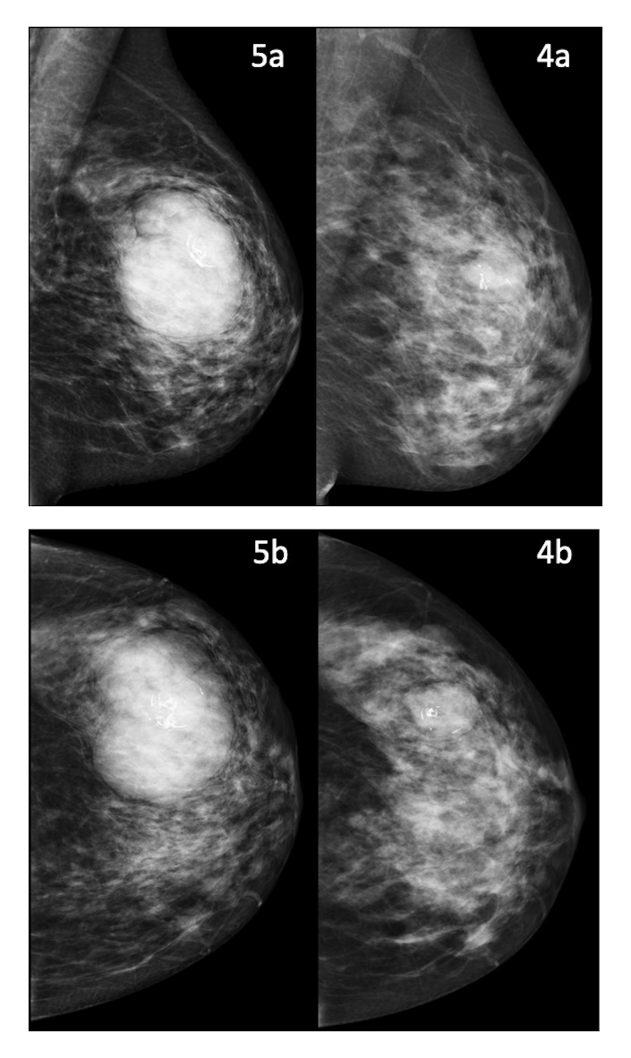

Left sided mammogram images showing growth of a fibroepithelial lesion, subsequently confirmed to be a malignant phyllodes tumour.
Image 4. September 2017: 23mm x 28mm well defined mass with coarse internal calcification.
4a. mediolateral oblique view, MLO
4b. Craniocaudal, CC
Image 5. December 2020: Re-presentation with recent increase in size. 70mm x 55mm mass encompassing the previous mass with a nodular outline.
5a. mediolateral oblique view, MLO
5b. Craniocaudal, CC

Supplementary Surveillance infographics
Infographic pathways for management and surveillance recommendations

Suspicion of phyllodes tumour

Discuss at local Breast MDT

Refer to Sarcoma MDT to decide unit for management

CT staging

MALIGNANT
Discuss at local Breast MDT
Proceed to surgery
BENIGN
Discuss at local Breast MDT

Refer to Sarcoma MDT to decide unit for management

Core biopsy or surgical histology result
Triple assessment

Breast Ultrasound
Mammography >40
Core biopsy
MRI as per local protocol
BORDERLINE
BENIGN PHYLLODES

Proceed to surgery
(Breast-conserving surgery vs mastectomy)

Margins: aim for complete excision with capsule intact

Involved margin: discuss re-excision
(87% do not develop a local recurrence)

Radiotherapy: not indicated

Surveillance:

Discharge with patient initiated follow-up

BORDERLINE PHYLLODES

Mastectomy
Breast-conserving surgery

Margins: aim for 5mm

Involved margins:
Recommend re-excision if margins <3mm

Consider risks and benefits of re-excision if margin 3-5mm

Adjuvant radiotherapy: not indicated

Consider adjuvant radiotherapy if further surgery not possible:
Large tumours (>5cm), infiltrative borders, close margins

Surveillance:
Breast imaging is not routinely required after mastectomy

6-monthly clinical surveillance for 3 years
Surveillance:
6 monthly USS of indexed quadrant for 3 years

Annual bilateral mammography for 5 years

MALIGNANT PHYLLODES

Mastectomy
Breast-conserving surgery

Margins: aim for 10mm

Involved margins: recommend re-excision if <5mm

Consider risks and benefits of re-excision if margin 5-10mm

Consider adjuvant radiotherapy:
Large tumours >5cm, close margins (although surgery to clear margins is preferable)

Consider adjuvant radiotherapy:
Large tumours >5cm, multifocal disease, close margins

Surveillance:
Clinical review (Oncology or Surgery) every 6 months for 3 years then annually for years 4 and 5

6 monthly USS of indexed quadrant for 3 years
Annual bilateral mammography for 5 years

Chest imaging every 6 months for 2 years then annually from years 3-5

Duration:
US F/U 24-36 months
MMG F/U 5 years

Surveillance:
Clinical review (Oncology or Surgery) every 6 months for 3 years then annually for years 4 and 5

Breast imaging is not routinely required after mastectomy

Chest imaging every 6 months for 2 years then annually from years 3-5

Supplementary Appendices

Appendix A: Summary of Consensus Recommendations for Clinical / MDT use.

Diagnosis
- The diagnosis of PT should involve triple-assessment with needle core biopsy of the lesion and indeterminate/ abnormal axillary lymph nodes if present (evidence/ grade IV/A).
- Core biopsy is recommended rather than fine needle aspiration cytology (FNAC) (evidence/ grade IV/A).
- All PT cases should be reviewed in a breast MDT meeting (evidence/ grade V/A).
- Given the challenges with histological classification of these lesions, referral for second pathological opinion should be considered in difficult cases (evidence/ grade V/B).
- Breast MRI is not routinely recommended for the diagnostic work-up of PT (evidence/grade IV/C).
- Pre-operative CT staging is not recommended for benign or borderline PT (evidence/ grade IV/D).
- Pre-operative staging CT chest is recommended for malignant PT (evidence/grade IV/A).
- MDTs should have a low threshold for diagnostic surgical excision biopsy when phyllodes cannot be excluded on needle biopsy (evidence/ grade V/A).
- Tertiary referrals for suspected or confirmed phyllodes should be directed towards the breast MDT for review and triage (evidence/ grade V/A).
Management of biopsy confirmed borderline and malignant PT should be referred and discussed at a sarcoma MDT with expert pathology review and shared care between breast and sarcoma MDTs is recommended (evidence/ grade V/A).
- MDTs should consider that surgical management of malignant PT is time sensitive and pathway delays should be avoided (evidence/ grade V/A).

Breast surgery
- For all PT, BCS can be offered if adequate surgical excision margins can be achieved (evidence/ grade IV/B).
- If complex oncoplastic techniques or mastectomy are required to achieve clear margins, this should be discussed at a local oncoplastic MDT with plastic and breast surgeons where available (evidence/ grade V/B).
  - Consideration should be given to individual patient risk factors including smoking, body mass index (BMI) and receipt of previous radiotherapy.
- Breast reconstruction should be offered to all patients undergoing mastectomy for PT, but for patients with malignant PT, careful consideration should be given to the timing of reconstruction including the likelihood of early progression (local and distant), operative recovery time, and potential effects on timing of adjuvant therapy (evidence/ grade V/B).
- Consideration should be given as to whether significant skin excision or chest wall musculature is required to achieve oncological margins (evidence/ grade V/B).

Axillary surgery
- Given the extreme rarity of axillary nodal involvement and the possibility of reactive lymph nodes, histopathological (e.g. by core biopsy) examination of suspicious nodes is recommended to guide the need for axillary lymph node dissection (evidence/grade IV/A).
- Axillary staging surgery, e.g. sentinel lymph node excision biopsy, is not recommended for any of the PT sub-groups (evidence/ grade V/E).
- In the case of biopsy-proven axillary nodal involvement, axillary lymph node dissection is indicated. Cases with locoregional spread should be discussed in a sarcoma MDT meeting (evidence/ grade V/A).

Resection margins
- For benign PT, aim for complete excision with the capsule intact (evidence/ grade IV/A).
- For benign PT, discuss with patient the risks and benefits of re-excision versus risk of local recurrence if the margins are involved after BCS (evidence/ grade V/A).
- For borderline PT, aim for a clear surgical excision margin of 5mm (evidence/ grade V/A).
- For borderline PT, if the surgical excision margins are <3mm after BCS, re-excision is recommended (evidence/ grade V/A).
- For borderline PT, if the surgical excision margins are 3mm to <5mm after BCS, consider re-excision versus clinical and imaging surveillance alone following discussion with the patient about the risks and benefits of each option (evidence/ grade V/A).
- For malignant PT, aim for a clear surgical margin of 10mm (evidence/ grade II/A).
- For malignant PT, if the surgical excision margins are <5mm after BCS, re-excision is recommended (evidence/ grade II/A).
- For malignant PT, if the surgical excision margins are 5mm to <10mm after BCS, whilst the recommendation is to re-excise, consideration of clinical and imaging surveillance alone may be appropriate following discussion with the patient about the risks and benefits of each option (evidence/ grade V/A).
- Discuss with the patient the uncertainty around optimal margin width for borderline and malignant phyllodes tumours (evidence/ grade V/A).

Adjuvant radiotherapy
- Adjuvant radiotherapy is not recommended in benign PT (evidence/grade III/A).
- In the majority of borderline PT, radiotherapy is not recommended, however, it may be considered in high-risk cases such as large tumours and/or infiltrative borders and/or positive/close margins when further surgery is not possible (evidence/grade III/A).
- In malignant PT, adjuvant radiotherapy should be considered in large tumours (>5cm) and in multifocal disease (evidence/ grade II/A).
- In solitary smaller malignant PT, radiotherapy may be considered if a surgical margin of 5mm was not achieved, and further surgery is not possible. Repeat surgery to achieve clear margins is preferable to adjuvant radiotherapy (evidence/grade V/B).
- In recurrent malignant PT, adjuvant radiotherapy should be considered, following surgical excision, if not previously received (evidence/grade V/B).
- The consensus recommendation for adjuvant radiotherapy dose is 50-66Gy (evidence/grade II/B) and hypo-fractionated regimens to an equivalent dose could be considered (evidence/ grade IV/B).
- TP53 testing eligibility should be considered prior to offering radiotherapy to evaluate the risk of development of radiation-induced secondary malignancies (evidence/ grade III/B).

Adjuvant chemotherapy
- Adjuvant chemotherapy is not recommended in the management of non-metastatic PT (evidence/ grade IV/A).

Surveillance
- Patient initiated follow-up without imaging surveillance is recommended for benign PT (evidence/ grade IV/B).
- For borderline PT, clinical surveillance every 6 months for 3 years, ultrasound of index quadrant (after breast conserving surgery) every 6 months for 3 years and annual mammography for 5 years is recommended (evidence/ grade IV/A).
- For malignant PT, clinical surveillance every 6 months for 3 years and then annually for years 4 and 5 is recommended (evidence/ grade IV/A).
- For malignant PT, ultrasound of index quadrant (after breast conserving surgery) every 6 months for 3 years and annual mammography for 5 years is recommended (evidence/ grade IV/A).
- For PT, breast imaging is not routinely recommended after mastectomy (evidence/ grade IV/ A).
- For malignant PT, chest imaging (Chest X-ray or low dose CT thorax) every 6 months for 2 years and then annually for years 3 to 5 is recommended (evidence/ grade IV/A).

Management of recurrent disease
- Locally recurrent PT should be treated with further surgical excision and with appropriate excision margins for benign, borderline and malignant types (evidence/grade V/A).
- Management of biopsy confirmed recurrent phyllodes should be referred to a unit with shared care from breast and sarcoma MDTs (evidence/grade V/A).
- In recurrent malignant PT, adjuvant radiotherapy should be considered, following surgical excision, if not previously received (evidence/grade V/A).
- In small volume oligometastatic disease, metastatectomy should be considered if appropriate, following sarcoma MDT discussion (evidence/grade V/A).
- In small volume oligometastatic disease where metastatectomy is not feasible/acceptable, SBRT could be considered (evidence/grade V/A).
- Metastatic malignant PT should be managed as per local guidelines for soft tissue sarcoma (evidence/grade V/A).
- Enrolment in clinical trials is highly encouraged (evidence/grade V/A).

Appendix B: Recommendations for topics to be included in patient information specific to phyllodes tumours:

Written patient information should include:
1. Classification of PT and difficulties in classification.
A. Which classification for the individual patient:
i. Benign
ii. Borderline
iii. Malignant
B. Long term outcomes.
i. Lack of long-term evidence
ii. Likelihood of recurrence

2. Information on “early-warning” signs for recurrence.
A. New mass in the breast or chest wall
B. Swelling
C. Systemic symptoms of recurrence, e.g., new persistent cough, unexplained shortness of breath, weight loss, malaise.

3. Information on what to do in the event of concerns about recurrence.
A. How to identify a problem
B. How to access help

Patient information sheets are available from Breast Cancer Now and Sarcoma UK:
https://breastcancernow.org/information-support/facing-breast-cancer/diagnosed-breast-cancer/primary-breast-cancer/borderline-malignant-malignant-phyllodes-tumours

